**Project Report: Mustang Nest Locator**

**1. Updated Project Proposal:**

The Mustang Nest Locator project aims to provide a user-friendly platform for finding apartments near Southern Methodist University (SMU). The scope of the project includes developing a Shiny web application that allows users to search for apartments based on location, price range, and number of bedrooms. Additionally, the app facilitates the submission and management of reviews for apartments.

**2. Conceptual Design (E-R Diagram) and Logical Design:**

E-R Diagram Design:

The Entity-Relationship (E-R) diagram for the Mustang Nest Locator project includes entities such as Apartment, Review, and User. Relationships are established between these entities to represent connections, such as a User submitting a Review for a specific Apartment.

Transformation and Normalization:

The E-R diagram was transformed into tables as follows:

Apartment Table: Contains details about each apartment, including ID, name, location, rent, bedrooms, bathrooms, and contact information.

Review Table: Stores user reviews for apartments, including the user ID, apartment ID, rating, comment, and date.

User Table: Manages user information, including user ID.

Normalization was applied to ensure data integrity and eliminate data redundancy. For instance, the User entity was separated into its table to avoid repeating user information for each review.

**3. Shiny User Interface Design and Workflow:**

User Interface (UI) Layout:

The Shiny app features a tab-based layout with sections for Home, Apartment Search, Submit Review, Manage Reviews, and Apartment Locations. The UI is designed with a dark theme, making it visually appealing and easy to navigate. Each tab has a specific purpose, creating an intuitive user experience.

User Workflow:

Home Tab: Welcome message and team information.

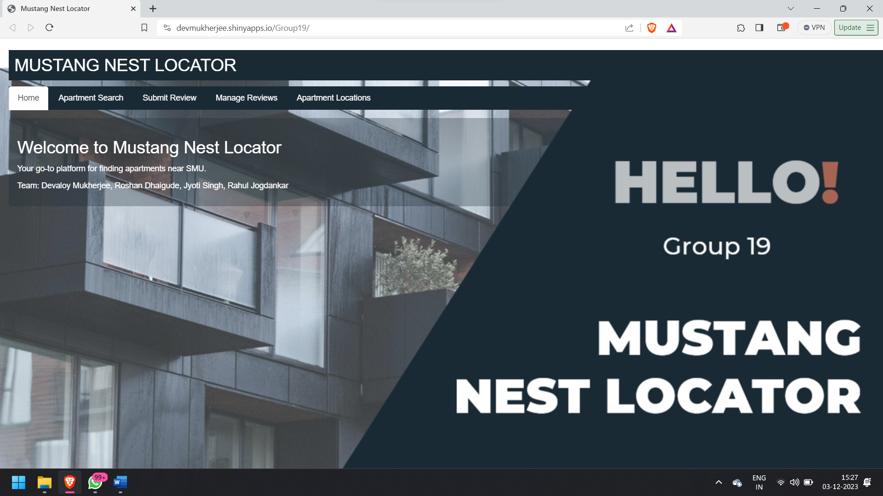

Apartment Search Tab: Users can filter apartments based on location, price range, and bedrooms. The results are displayed in a dynamic table.

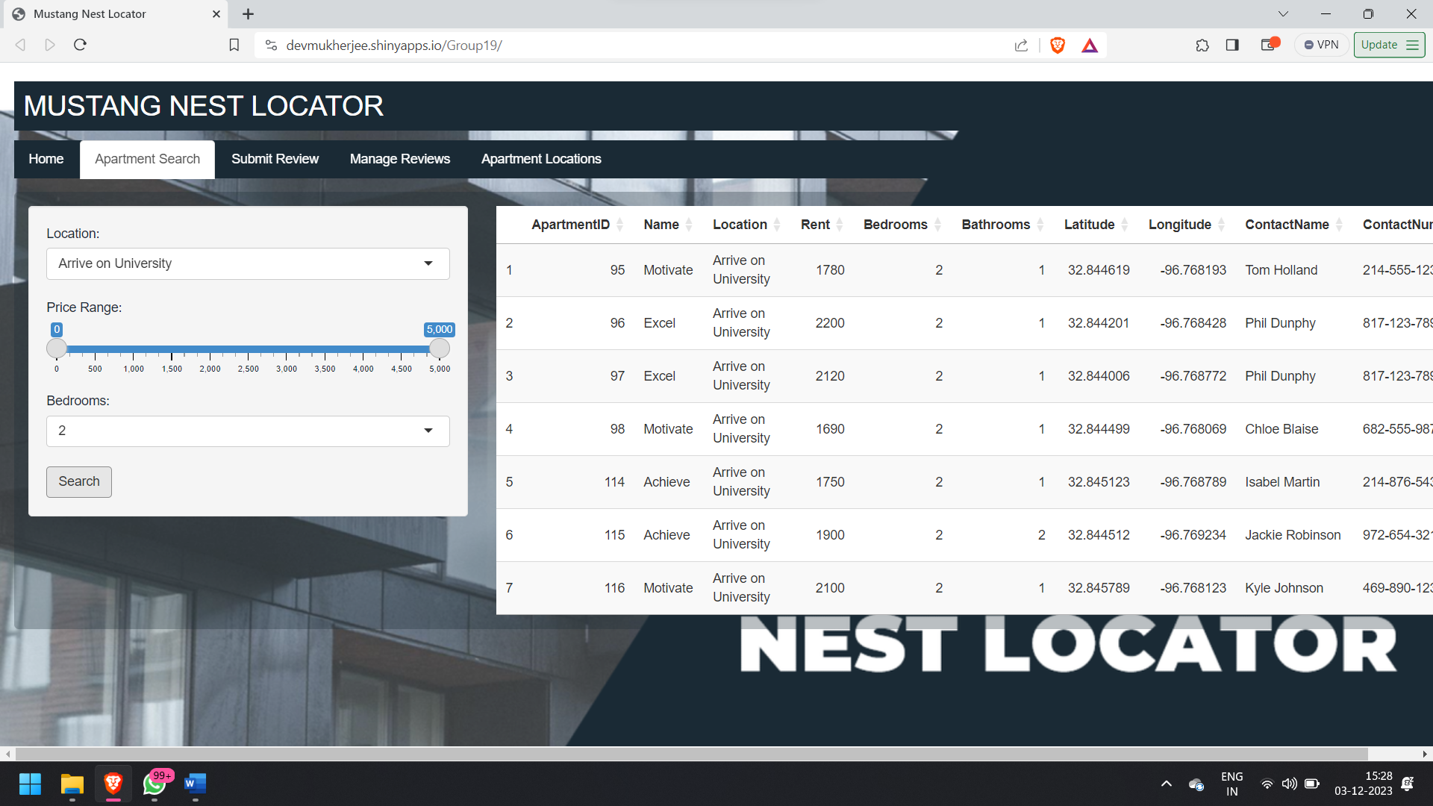

Submit Review Tab: Users can submit reviews, providing their user ID, apartment ID, rating, comment, and date.

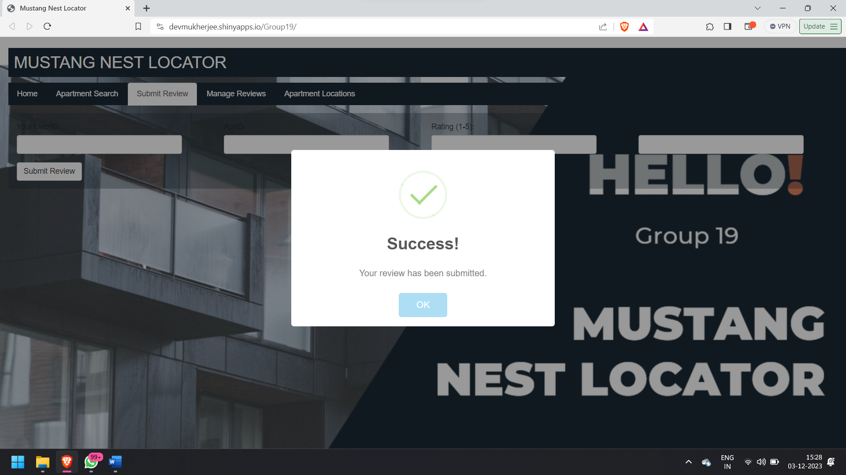

Manage Reviews Tab: Allows users to view and update their reviews, including the ability to update ratings and comments.

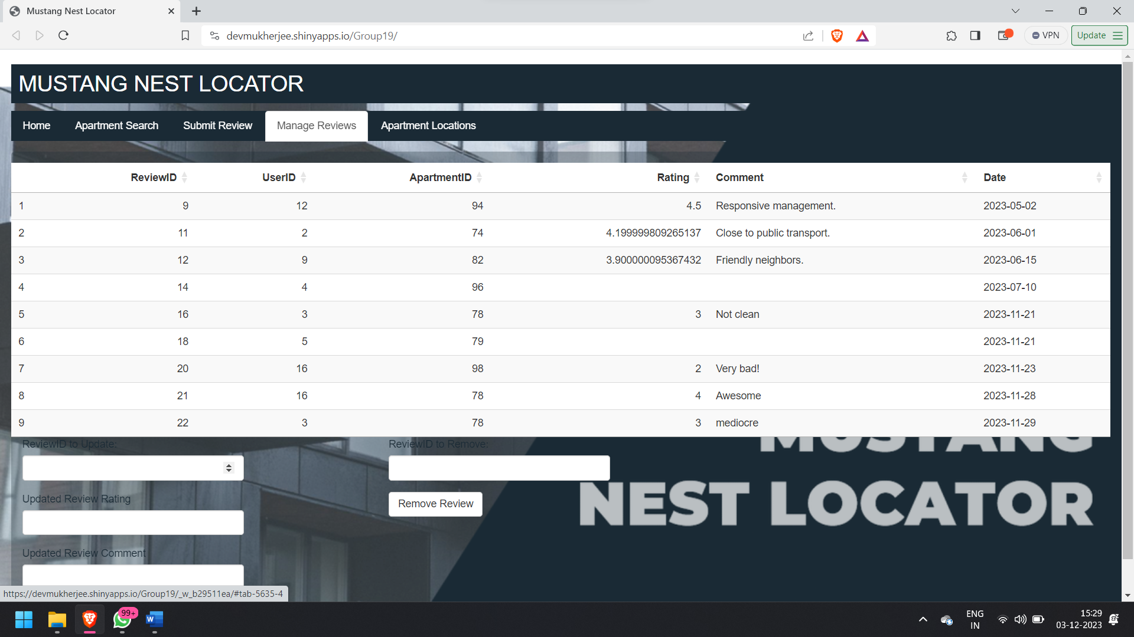 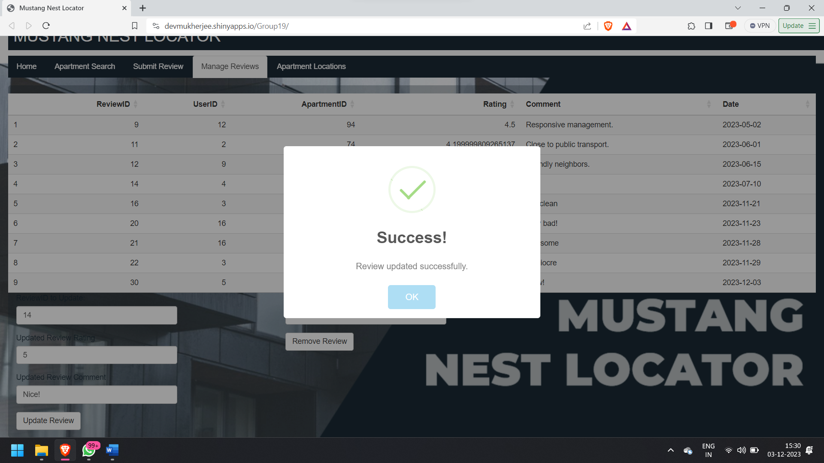 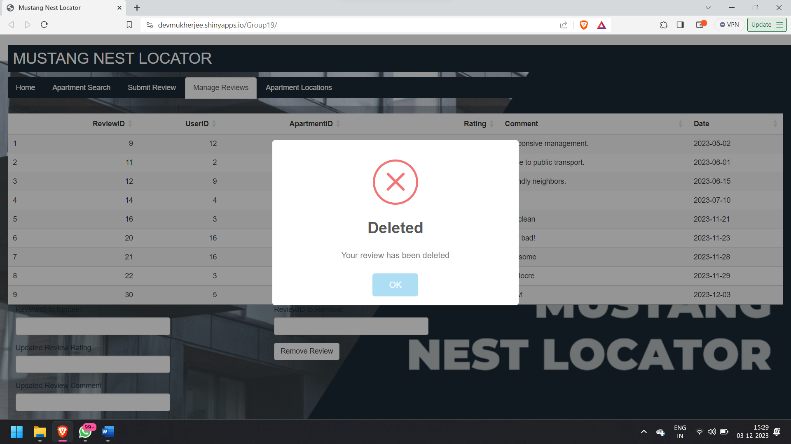

Apartment Locations Tab: Displays a map with markers for apartment locations and a marker for SMU.

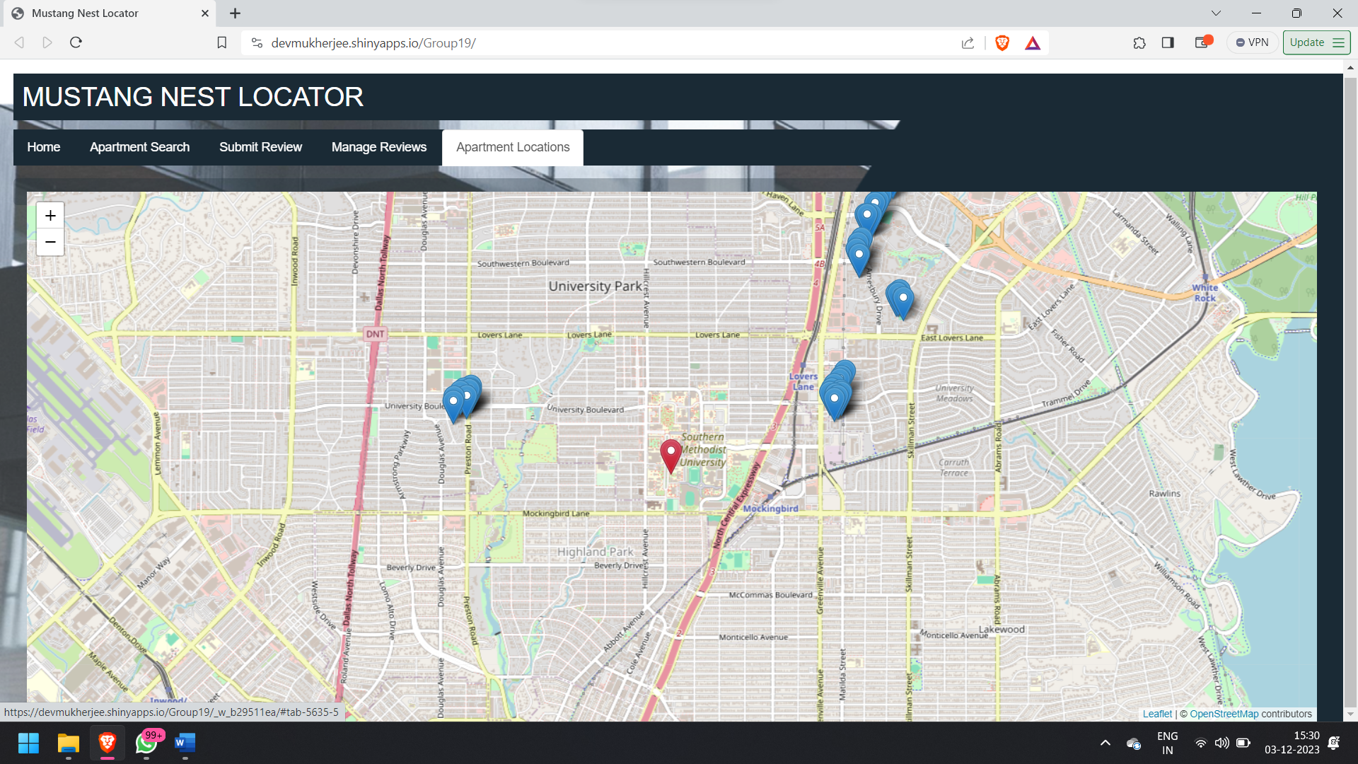

**4. Relationships and Data Dictionary (Appendix):**

Relationships:

Apartment-Review Relationship: One-to-Many relationship, as an apartment can have multiple reviews.

Data Dictionary (only relevant to the current design):

* Apartment Table
  + ApartmentID: Unique identifier for each apartment.
  + Name: Name of the apartment.
  + Location: Location of the apartment.
  + Rent: Rent amount for the apartment.
  + Bedrooms: Number of bedrooms in the apartment.
  + Bathrooms: Number of bathrooms in the apartment.
  + Latitude: Latitude coordinates of the apartment location.
  + Longitude: Longitude coordinates of the apartment location.
  + ContactName: Name of the contact person for the apartment.
  + ContactNumber: Contact number for the apartment.
* Review Table:
  + ReviewID: Unique identifier for each review.
  + UserID: User ID associated with the review.
  + ApartmentID: Apartment ID associated with the review.
  + Rating: Rating given in the review (1-5).
  + Comment: Comments provided in the review.
  + Date: Date when the review was submitted.
* User Table:
  + UserID: Unique identifier for each user.

**5. Conclusion:**

The Mustang Nest Locator project successfully combines a well-designed database schema with an intuitive Shiny app interface to fulfill the goal of providing a convenient platform for apartment search and review management near SMU. The project ensures data integrity, user-friendly navigation, and an aesthetically pleasing design.

**6. Link:** [**Mustang Nest Locator**](https://devmukherjee.shinyapps.io/Group19/)

Top of Form